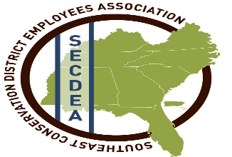
Benevolence Request
Name_______________________________________________
Phone number________________________________________
Address_____________________________________________
Please describe as fully as you feel comfortable, the
hardship you are experiencing:
________________________________________________________________________________________________________________________________________________________________________________________________________________

The Benevolence Committee will base assistance on availability of funds and the amount of assistance needed (not to exceed $500).

Your request will be kept in confidence. Only the Benevolence Committee will have access to the information on this form. It is the goal of the SECDEA to assist fellow employees in every way possible, unfortunately, funding plays a major role in the effectiveness of this program, we may be unable to fund all request.

The SECDEA is committed to this endeavor and will continue its support. It is our hope that the difficulty you are experiencing will soon pass.

Please submit this request form to:

Nancy Melancon
2660 Sherman Avenue
Vicksburg, MS 39183
Office: 601-630-0278 ext. 3
Cell: 601-218-2352

